**Code Completion Tracker [ CCT ] – Usage Guide**

Find below the screen shots showing the step-by-step usage of the CCT.

**Step 1 : Login – Credentials are same as PBLApp**

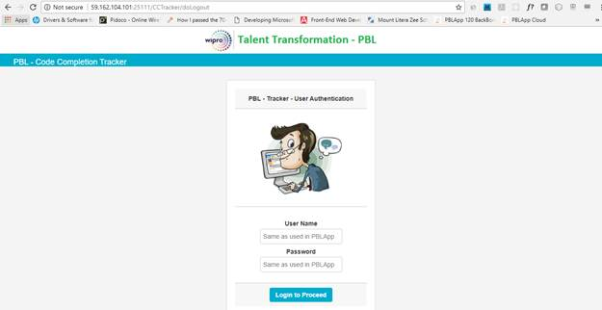

**Step 2 : Once a candidate logged in, the below screen opens showing all the Tech modules according to the participant training stream mapped.**

·         The upload instructions are provided at the top.

·         The submission status against each TM is shown as below

·         If no uploads are done against a TM,  No Submissions in Red appears

·         If uploads are done, then it shows the number of submission and the name of the files uploaded.

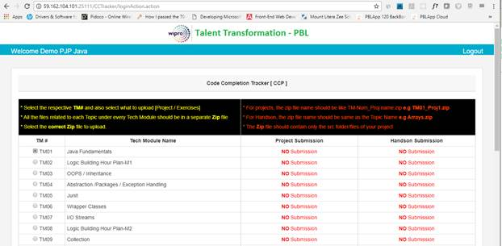

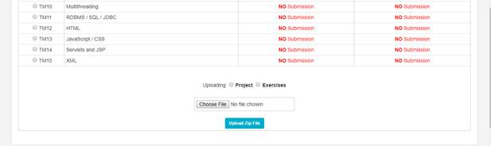

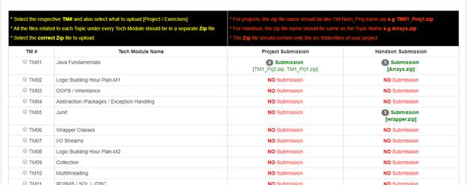

**Step 4 : Uploading the Zip files**

·         The participant should select the appropriate TM by clicking on the radio button against the TM

·         Should select either Project or Exercises at the bottom

·         Select the correct zip file by clicking the Browse button

·         Click the upload button

·         If error occurs during file upload like not selecting TM or Invalid file format, the respective error message will be shown as below

·         On successful upload, success message with the file name and Date and Time stamp will be displayed.

